BEGINNERS CHORDS - CHANGING
“G” and “Em SHAPE” CHORDS
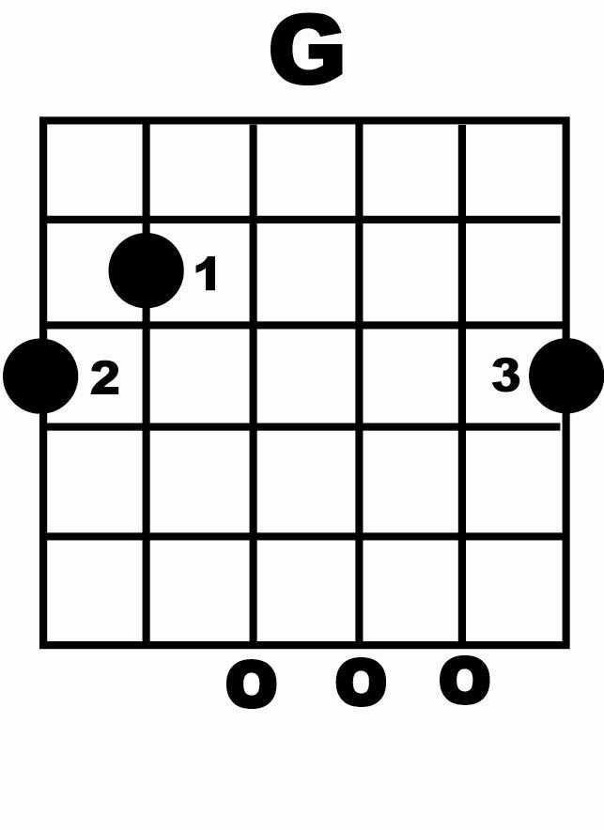
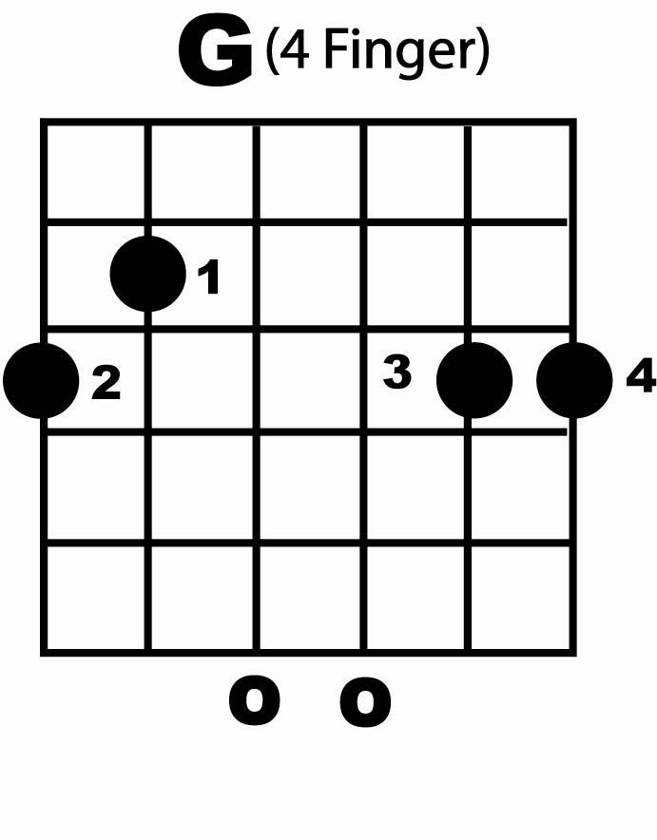
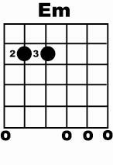
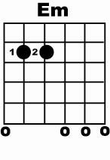

DO play the O’s
DON’T play the X’s in the case of a full G chord all strings are strummed.

= downstroke = upstroke

First just try a few downstrokes and upstrokes to get used to strumming in both directions then see if you can follow these patterns playing in time:

G G
    

Em Em
    

G G
    

G (4) G (4)
    

Combining G and Em Chords:

G Em
 

G (4) Em
 

NOTE:

Make sure all chords sound “clean” i.e, no buzzing from strings etc…if you hear a “buzzing” sound just practice picking through each string one a time until this goes away.

Keep all the rhythms smooth and even don’t rush the rhythm. Playing rhythm in songs requires a consistent flowing style – so take your time with it.

